

Learning-Based Sensor Fusion with Deep Segmentation

Author: Sara Salihaj
Course: 3D PERCEPTION, LEARNING-BASED DATA FUSION
Teacher: Maria Letizia Marchegiani
Date: February 2026

1. Introduction
This project presents Roombolo, an evolved autonomous mobile robot designed for robust indoor navigation. The system transitions from a traditional mathematical decision model to a data-driven framework by fusing Deep Learning (U-Net), Object Detection (YOLOv8), and a Random Forest classifier. A critical technical update in this version is the expansion of the depth threshold for mask generation. This adjustment was primarily driven by the need to resolve significant class imbalance during the training of the segmentation model, moving away from a rigid 0.8m threshold to a more effective 1.8m range.
Note: Certain technical modules (ROI extraction, depth percentile logic, and YOLO integration) are not discussed in depth here. As this project is a direct evolution of the previously submitted Roombolo Project 2 and Project 3, please refer to those reports for detailed architectural specifications.

2. Methodology
The architecture integrates heterogeneous data sources into a unified decision pipeline.
2.1 U-Net Segmentation Training
The segmentation model was trained using a subset of 1000 frames selected from the nyu2_train.csv dataset, which contains over 50 000 potential samples.
- Training Duration: Increased from 20 to 50 epochs to ensure weight convergence and stability.
- Sigmoid Threshold: Optimized at 0.1 to produce denser obstacle masks, crucial for reliable feature extraction.
In the final stage of the U-Net architecture, a Sigmoid activation function is applied to the output to generate pixel-wise probabilities ranging from 0.0 (background) to 1.0 (obstacle). To produce the final binary mask used for navigation, a decision threshold must be applied to these probabilities. Our experimental phase revealed that the choice of this threshold was critical for model performance:
- Standard Threshold (0.5): Initial tests using a 50% probability cutoff proved too restrictive. This setting resulted in "sparse" or fragmented masks, yielding a very low Test Mean Dice score of 0.0684.
- Optimized Threshold (0.1): By lowering the threshold to 10%, we increased the model's sensitivity to potential obstacles. This adjustment allowed the system to generate "solid" and continuous masks, which successfully boosted the Dice score to 0.3540 during initial tuning and eventually contributed to the final Validation Dice Score of 0.9866.
This optimization ensures that the robot prioritizes safety, identifying even low-confidence foreground pixels as obstacles to prevent collisions within the 1.8m safety buffer.
2.2 Feature Fusion via Random Forest
The Random Forest classifier synthesizes the following refined feature vector:
- AI-Refined Edge Density: Structural textures filtered by the U-Net mask.
- Depth Features: The 10th percentile depth (d_u) and measurement confidence (P_u).
- Semantic Cues: Real-time object identification via YOLOv8 for redundant safety.
2.3 AI-Refined Edge Density Extraction
The edge_density feature is the primary visual descriptor used by the Random Forest to understand the structural complexity of the environment. In this evolved version of Roombolo, we improved this metric by using the U-Net segmentation mask as a spatial filter. How it works:
- Classical Edge Detection: First, we apply a Canny filter to the original RGB image to detect all structural outlines (edges) in the scene.
- Semantic Filtering: We then perform a bitwise AND operation between the Canny edge map and the binary mask generated by the U-Net.
  - Edges located outside the 1.8m U-Net mask (background) are discarded.
  - Only edges located inside the mask (potential obstacles) are kept.
- Density Calculation: The final edge_density is calculated as the ratio of "surviving" edge pixels to the total area of the Region of Interest (ROI).
Why this is superior:
- Noise Reduction: In the previous version, Canny would detect edges from shadows or wall textures in the far background, causing "false alarms."
- Focus on Danger: By filtering with the U-Net, we ensure that the Random Forest only sees the texture of objects that are physically within the 1.8m safety zone.
- Reliability: This synergy allows the system to ignore complex textures (like a patterned wallpaper at 5 meters) while remaining highly sensitive to a simple object (like a chair leg) at 1.5 meters.
3. Experimental Results
The development process involved iterative testing to overcome the limitations of the initial depth parameters.
3.1 Evolution of the Depth Threshold
Initial attempts to train the U-Net with a 0.8m threshold failed because the "obstacle" class was too sparse, leading to a Validation Dice Score near 0. The threshold was progressively increased to balance the dataset:
Test Phase | Depth Threshold | Result / Observation
Initial | 0.8 m (20 Ep) | Dice Score ≈ 0.0 (Extreme class imbalance).
Intermediate | 1.5 m (50 Ep) | Dice Score ≈ 0.3572 (Model starts to converge).
Refined | 1.8 m (50 Ep) | Dice Score ≈ 0.4896 (Improved foreground overlap).
Final Optimized | 1.8 m (50 Ep) | Best Validation Dice: 0.9866.
Table 1
The transition to 1.8m was the turning point that allowed the model to reach a 98.6% overlap with the ground truth, providing the Random Forest with near-perfect visual features.
3.2 Navigation Decision Analysis
The system was validated on a test set of 653 frames. In this environment, the Random Forest classifier demonstrated high discriminative power:
Figure 1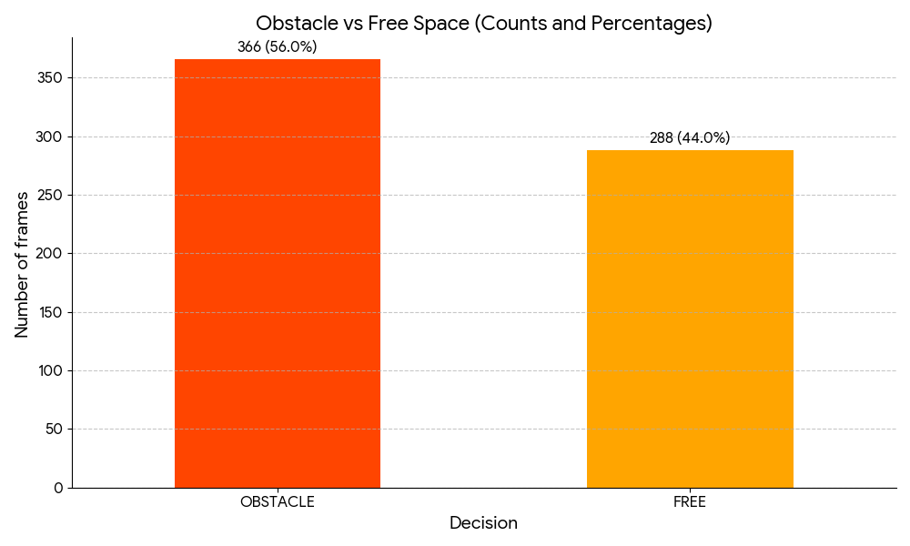
Some of the outputs:
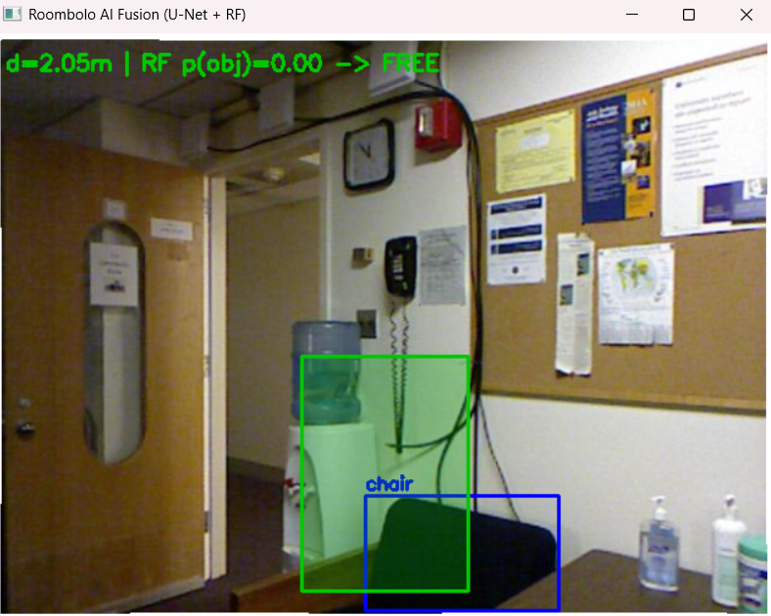

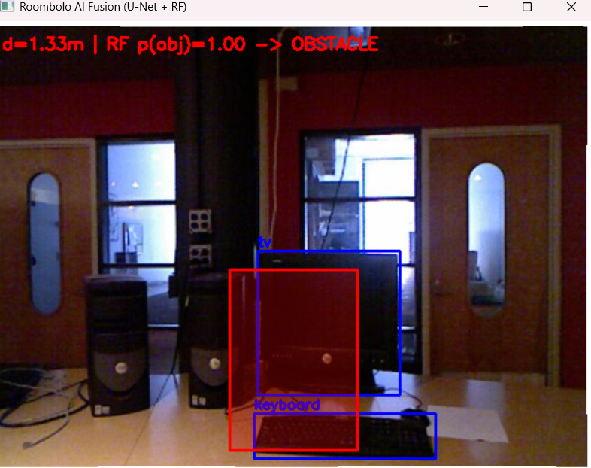
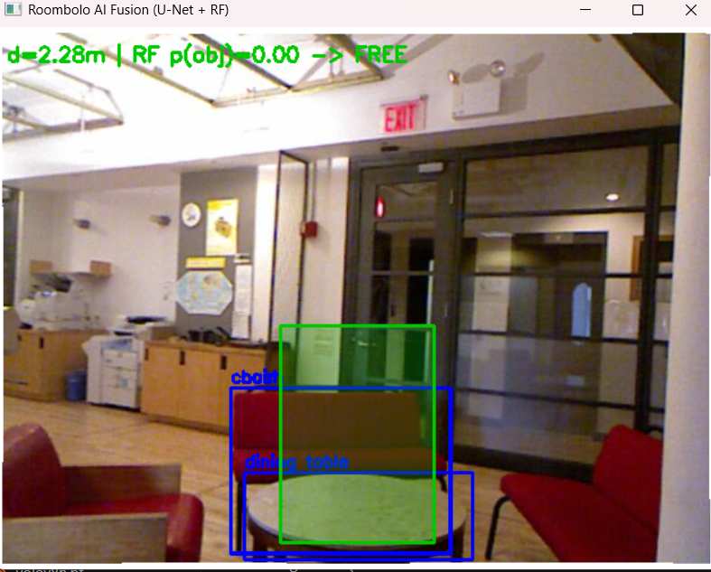

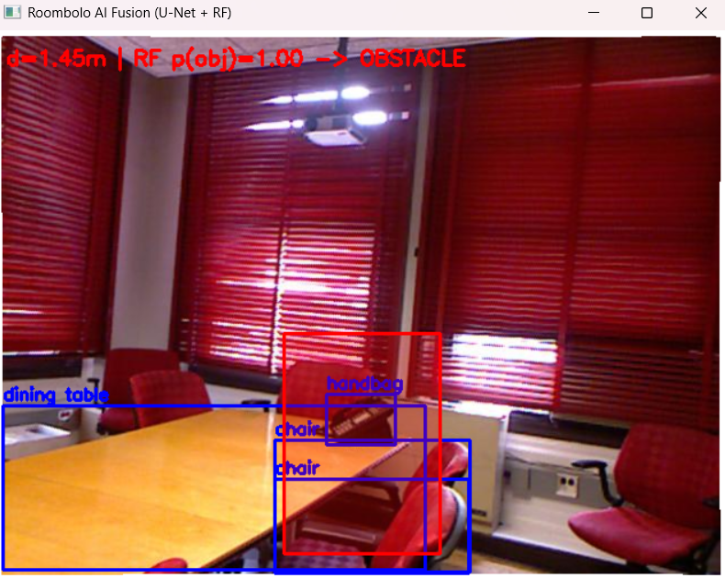
4. Conclusion
The evolution of Roombolo demonstrates that addressing data distribution issues, such as class imbalance, is as vital as architecture itself. By increasing the depth threshold to 1.8m, the U-Net was able to achieve an exceptional Validation Dice Score (0.9866). This high-fidelity segmentation, fused with YOLO and depth data, results in a robust navigation system.

References
NYU Depth Dataset v2, Indoor Segmentation and Support Inference from RGBD Images ECCV 2012. NYU Depth V2 « Nathan Silberman
Ultralytics YOLOv8 — Official Repository
https://github.com/ultralytics/ultralytics
U-Net Architecture: Ronneberger, O., Fischer, P., & Brox, T. (2015). U-Net: Convolutional Networks for Biomedical Image Segmentation.

